Hoodview Amateur Radio Club, WB7QIW, is offering

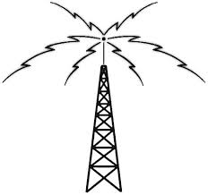 |  | Technician  Amateur Radio  License Classes  Mt. Hood Community College  Room Fisheries#1  (north-eastside of campus)  Gresham, Oregon
Class: | Technician License Class – Two Saturdays:  March 2nd at 9:00 am to 4:00 pm and  March 9th at 9:00 am to 4:00 pm
VE Testing: | March 16th, 2018 at 8:30 am (VE cost is $15.00)
Textbooks: | Ham Radio School, Technician License Course by Stu Turner, W0STU (Cost is $23)
Links: | Website: http://www.hamradioschool.com  Technician Course Outline: http://www.hamradioschool.com/tech_media  Technician Book: http://www.hamradioschool.com/tech-license-book
Contacts: | Cory Schoch KA7IUG at ka7iug@frontier.com or  503-781-9095 for more information and registration.  Check out our webpage for more details at www.wb7qiw.org

